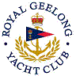 | Royal Geelong Yacht Club Inc.  Est 1859
Trophy Deed of Gift.

Trophy: | Montgomery Family Perpetual Trophy
Presented by: | Geoff & Gaye Montgomery
Date: | Circa 1995
For: | Keelboat Lady Skippers Race
Remarks / Revisions | Open to Div 1, 2 and 3 Division Keelboats
Click here to View Recipients

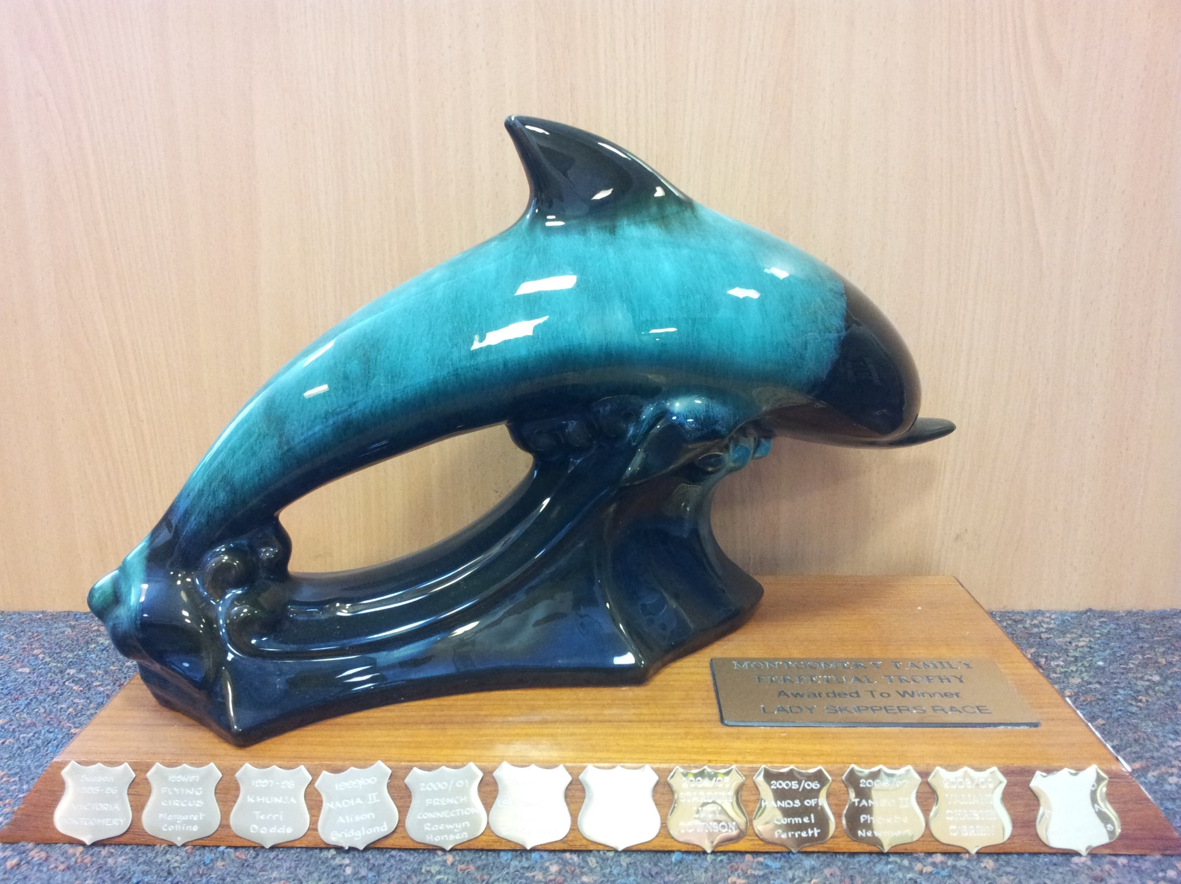

Synopsis
The Montgomery Family Trophy is awarded to the winning lady skipper for first place on handicap in the Lady Skippers Race. The trophy has been awarded each year since Season 1995/96.The aim of the trophy is to foster ladies racing and skippering yachts at the Royal Geelong .
A race called the Lady Skippers Race was held before 95/96 however it is unclear how many times the race was run or even who the winners might have been as there was no trophy awarded. When my daughter, Victoria, at the age of 18, won it on our yacht San Rafael, I felt compelled to celebrate the win and also record it properly in the Yacht Club history. I therefor made the trophy and a miniature and deeded it to the club to secure the running of the race into the future and for posterity record the names of the winners.
Such is the interest and prestige that this award has gained that over the years the trophy has been hotly contested and sometimes not without disputes requiring protest room discussions and rulings. These contests I am pleased to say embrace the ideals on which the trophy was gifted and that is to encourage lady skippers to contest and enjoy this wonderful sport of yacht racing.

Geoff Montgomery
Dec 2018

